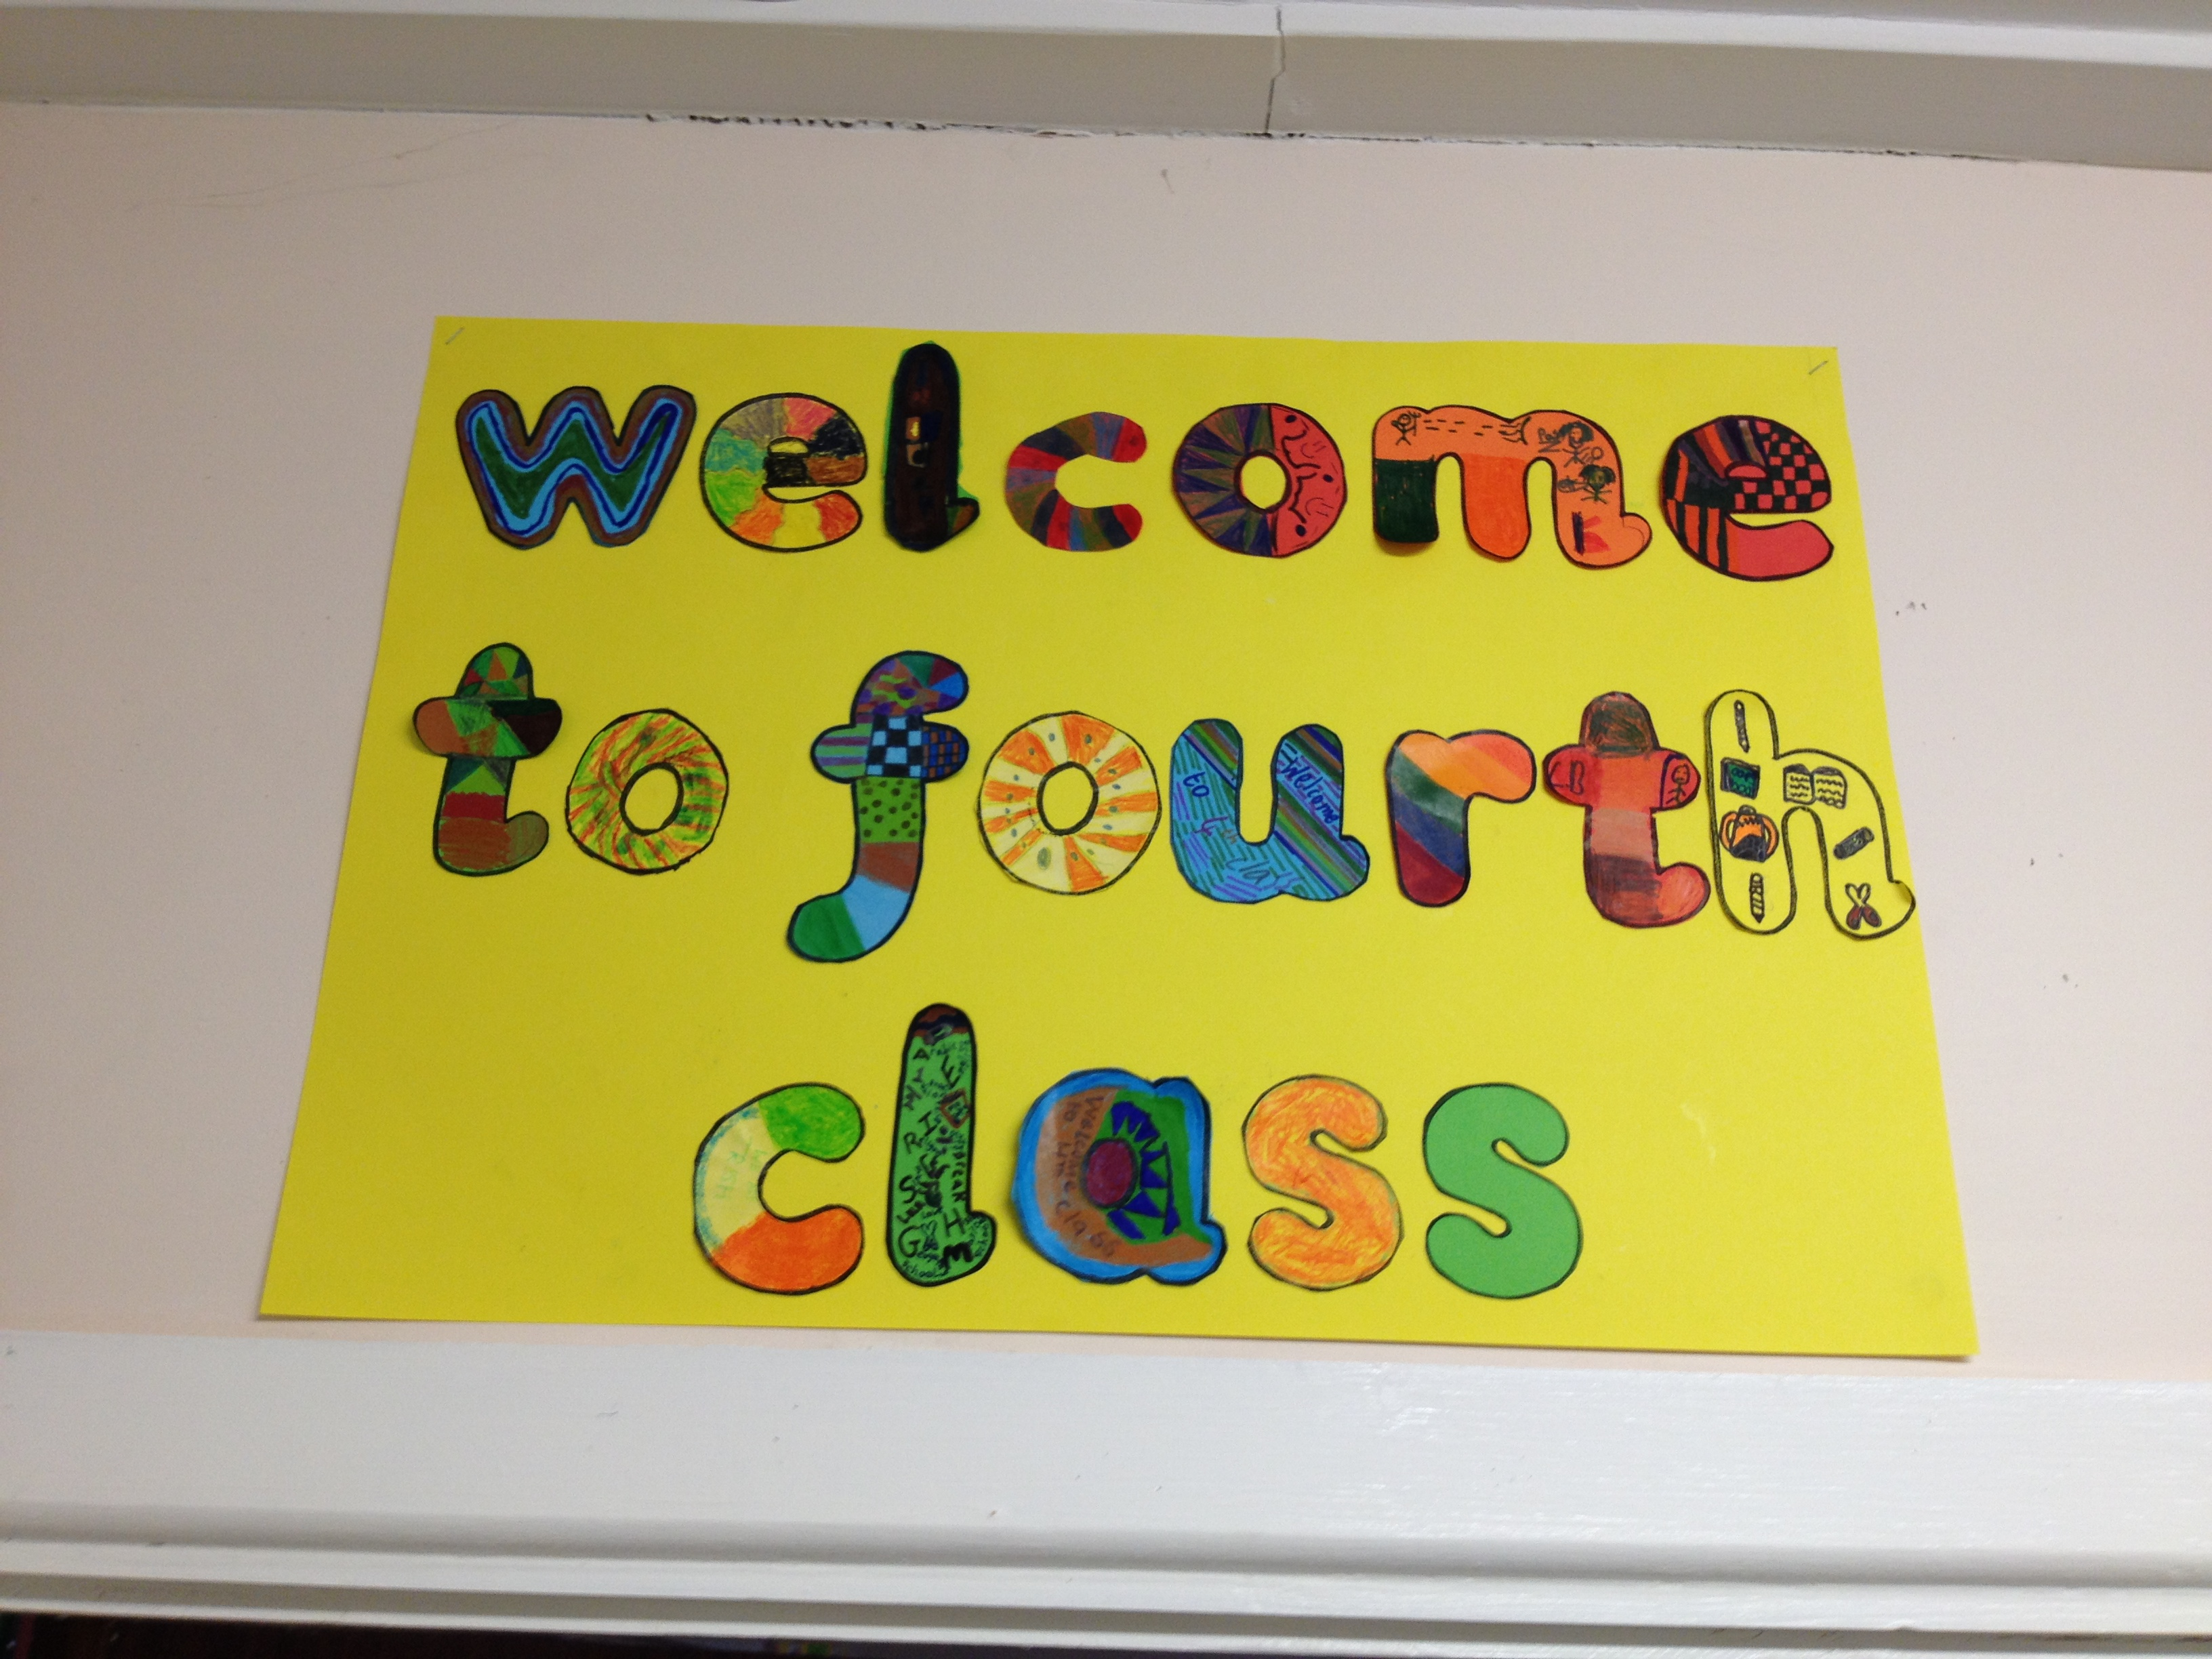
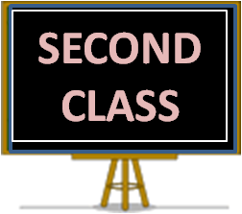
Games: Mon – 2nd Class Hockey

PE : Tuesday

Swimming: Term 2

